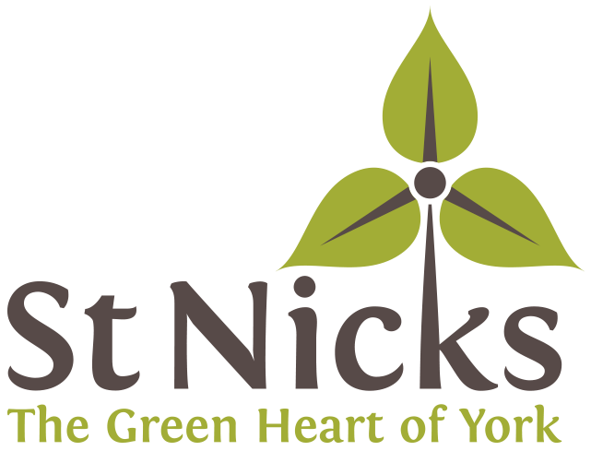

Recruitment Pack and Application Form

**Vice Chair**

**Board of Trustees**

FRIENDS OF ST NICHOLAS FIELDS

October 2024

|  |  |
| --- | --- |
|  |  |
|  |  |

**An introduction from the Chair.**

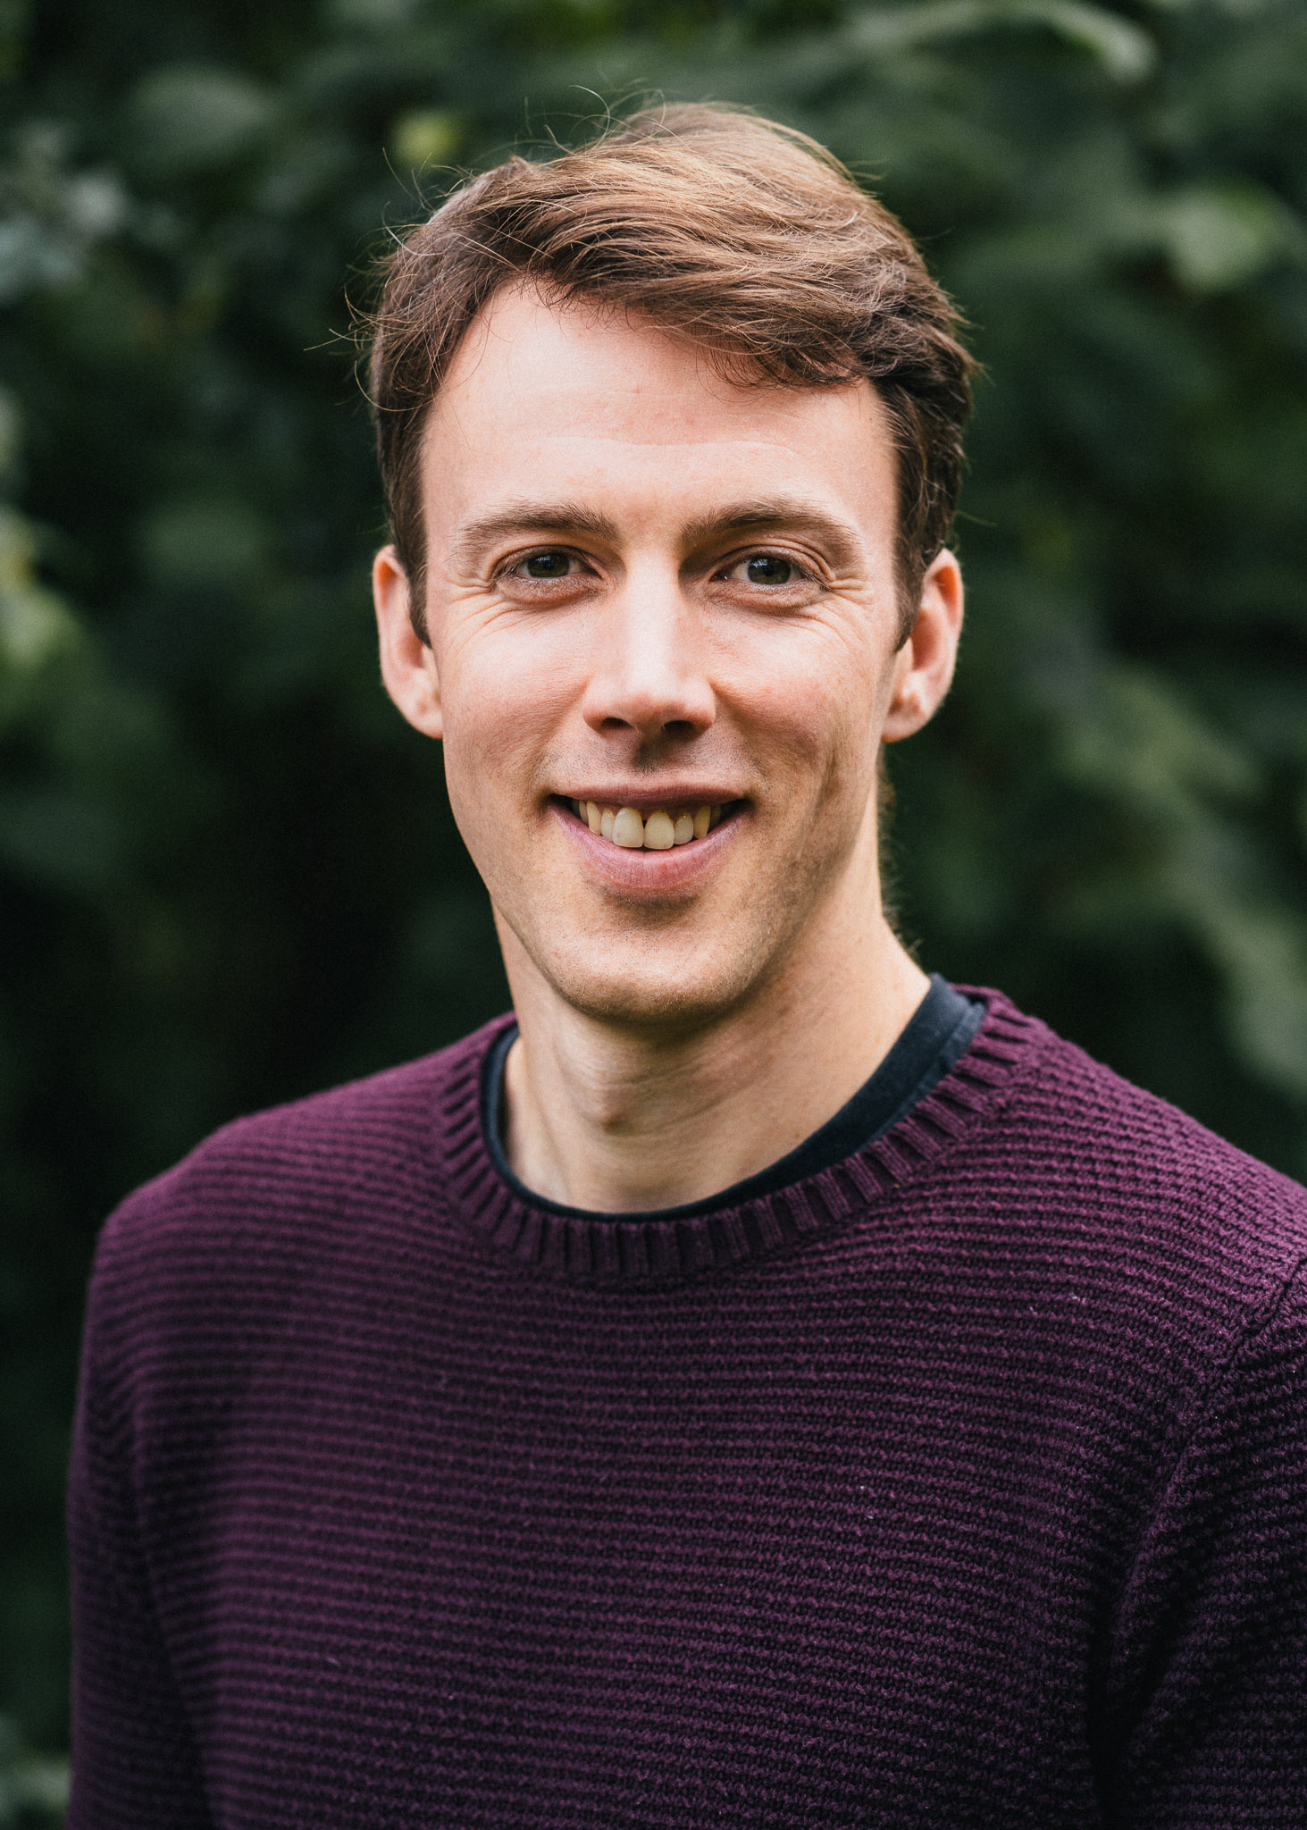

Thank you for your interest in this role!

We are looking for an enthusiastic and strategic individual to join our Board as our new Vice Chair.  We are a well-established, high-impact charity with a friendly and dedicated team of staff, trustees and volunteers.  We are at an exciting stage of our journey, having recently undergone a period of rapid growth and appointed a new CEO. We are looking to update our Environment Centre located on our 24 acre nature reserve in York. This year sees the 20th anniversary of our building’s original construction and we need to both improve and adapt the space to suit our needs and continue to align to our environmental credentials in relation to retrofitting and sustainability.

The role of Vice Chair is a strategic one, as part of our executive committee, acting as a sounding board for the Chair and deputising where required.

This pack contains key information about us and the role.  Please don’t hesitate to get in touch with me if you have further questions or would like to have an informal chat.

Kind regards – Stuart Leslie (Chair of Trustees)

**About St Nicks**

St Nicks is the green heart of York: a centre for nature and green living, with an ambitious vision to enable thriving and connected biodiverse communities. The charity started as ‘Friends of St Nicholas Fields’ in the 1990s by transforming a former landfill site into a thriving Local Nature Reserve. Over the years, our size and ambition has grown, and we have become an established and valued part of our city community.

Our current mission is to build and connect flourishing communities through urban greenspace regeneration, nature-based wellbeing and sustainable living. These activities are underpinned by our values of collaboration, integrity, innovation and professionalism, and focus on three core strategic aims:

* “Nature” - greenspace regeneration
* “People” - improving wellbeing through nature connectedness
* “Planet” - empowering communities to flourish sustainably

We have a passionate team of staff and volunteers who run a range of projects, events and services with the help of partners and supporters to help us achieve these aims.

We are partially funded by City of York Council and partly by grants from other sources. The rest of our income comes from membership, donations, fundraising events and other activities.

**Our Commitment to Quality & Diversity**

We are fully committed to making sure that our services, special places and the support we offer are as **welcoming**, **inclusive** and **accessible** as possible.

We want St Nicks to reflect a **diverse** society where we learn from each other and build a healthy respect for each other, both so that we can thrive together today and so that we can live together as sustainably as possible in the future.

We will strive to ensure that people of **all backgrounds and characteristics** are able to fully gain from and contribute to St Nicks, and we are committed to listening to everyone in our community to make sure that this is the case, identifying and addressing issues as they arise.

**The Board of Trustees**

We have an engaged board of trustees with a broad skillset. Our trustees play an important role in shaping the direction of our charity; overseeing our work and ensuring we are meeting our charitable objectives. We also encourage trustees to join in social events with our staff and broader community and volunteers. As Vice- Chair you would join our “Exec” leadership team, which includes the Chair, Treasurer and Secretary.

In seeking new trustees we are keen to build diverse team with different skills and talents to help the charity continue in its journey of growth and evolution.

St Nicks is committed to equality, diversity and inclusion in our recruitment process and elsewhere and we encourage applications from a diverse range of people including those with disabilities, those from Black and Asian and minority ethnic groups, those from the LGBTQ+ community and those from disadvantaged or non-traditional backgrounds.

**Next steps**

Please read the role description below then complete and return the very short application form in this pack.

Please do have a look at our website [stnicks.org.uk](https://stnicks.org.uk/) to find out more about us, or email Stuart Leslie on [chair@stnicks.org.uk](mailto:chair@stnicks.org.uk) if you have questions, or would like more information.

Please contact us on [info@stnicks.org.uk](mailto:info@stnicks.org.uk) if you would like an audio or a large print application form, if you have other accessibility needs or if you would like help with applying.

**Vice Chair Role Description**

The role of Vice Chair at St Nicks is a voluntary (unpaid) position. It provides an opportunity to give something back to the local community and use your skills and experience to make a meaningful difference to the environment and the lives of others.

As well as undertaking the role of Trustee to:

* Ensure that we deliver on our strategic and business plans, achieve financial sustainability and manage our organisation’s performance;
* Ensure that St Nicks complies with its governing document (its Articles of Association), charity law, company law and any other relevant legislation or regulations;
* Ensure that St Nicks pursues its objects as defined in its governing document;
* Ensure that St Nicks applies its resources exclusively in pursuance of its objects ;
* Contribute actively to the Board of Trustees by giving firm strategic direction to St Nicks;
* Set overall policy, defining goals, setting targets, and evaluating performance against agreed targets;
* Ensure the financial stability of St Nicks

The Vice Chair will also join the Board of Trustees’ Executive Committee and will also work closely with our CEO to:

* Act as a sounding board for the chair/CEO
* Share tasks with the chair when agreed, ensuring a manageable workload
* Be the chair's deputy in times of absence
* Run board meetings as requested and in the board chair’s absence
* Serve as a spokesperson for St Nicks as needed
* Prepare to assume the office of the board chair
* Fulfil the board chair’s duties when the presiding officer is absent or if that office becomes vacant

Examples of chair tasks that may be shared or deputised:

* Working with the CEO to set the trustee board agenda
* Recruitment of trustees
* 1-1s and appraisals with the CEO

**What would that mean for you?**

As a Trustee, the Vice-Chair would be expected to attend Board meetings every two months. These are friendly and informal sessions, at which Trustees review what has happened since the last meeting, hear from the Chief Executive and take any decisions that need to be taken. They are usually held in the evenings between 6 and 8 pm.

In addition, as a member of the Executive Committee you would be expected to meet with the other committee members every two months (alternate months to the Board), for up to two hours per meeting, to review and resolve any urgent matters between Board meetings and to prioritise matters for discussion at the next full Board meeting.

If you are selected, we will make sure that you are properly inducted to the Board of Trustees, have a mentor while you are learning about your role and have regular reviews with our Chair.

You will be responsible to the Chair of the Board of Trustees.

**Application for role of Vice Chair**

Thank you for your interest in the role of Vice Chair at St Nicks. To help us in the recruitment process we would like to find out a little bit more about you. Please answer the following questions and return your completed application to St Nicks by email on: [chiefexec@stnicks.org.uk](mailto:chiefexec@stnicks.org.uk)

Or by post or by hand to:

St Nicks Environment Centre

Rawdon Avenue

York

YO10 3FW

|  |
| --- |
| **Name**:  **Address**:  **Email**:  **Tel/mobile no**: |

|  |
| --- |
| **Why are you interested in joining St Nicks as Vice Chair?** |

|  |
| --- |
| **What experience and expertise would you bring to St Nicks? (Please refer to the Vice Chair role description.)** |

|  |
| --- |
| **Do you know of any reason which would prevent you from becoming a charity trustee e.g., undischarged bankruptcy, unspent conviction for deception or dishonesty, or previous disqualification as a charity trustee?**  I declare this information to be true.  **Signed[1]:**  **Date**: |

1. You can type your name here or use a digital signature if you are submitting your application by email.